Christopher Wilson
8/31/2026
CS-660 Module Nine Project

- Describe how abstraction and encapsulation are used in the current system to manage data and functionality.
In the current system, abstraction separates the functionality into modules such as order.c/.h and inventory.c/.h. Each module handles a different part of the system. For example, the inventory module has functions like add_item() and remove_item() that other parts of the program can use without needing to know how the functions work internally. The header files contain the function declarations, while the source files contain the actual implementation. For encapsulation, the system uses structures and functions together, such as a struct Item with an init_item() function. But the fields in the structures are exposed, so other parts of the program can directly access and change the data. The system also uses shared global data, such as static arrays for cached stock counts, which can create tight coupling and make the system harder to test and maintain. Overall, the system has basic abstraction, but its limited encapsulation and shared data make it harder to maintain as the system grows.
- Evaluate the legacy programming language against defined criteria. Your evaluation must address the following criteria:
  - Readability
  - Maintainability
  - Performance
  - Ecosystem support
The legacy system uses C99, which has some advantages but also some problems. For readability, the code can be harder to understand because of pointer arithmetic, manual memory management, and the different coding styles added over the years. For maintainability, manual memory management, global variables, and SQL being directly in the C files make the system harder to change and test. C has good performance because it is a low-level language with little overhead, but the global lock for inventory updates limits how many transactions can happen at once, with the system currently reaching about 220 transactions per second. For ecosystem support, C has mature compilers and tools, but it has fewer modern libraries for things like REST APIs, JSON, and database access. Overall, C has good performance but is harder to read, maintain, and scale for a modern system.
- Analyze the type system used in the legacy language. Include the following:
  - Whether the type system is static or dynamic
The current system uses a static type system because it checks variable types during compilation rather than while the program is running. This helps find some of the errors before the program runs (Cornell, n.d.).
  - Whether the type system is strong or weak
The current system uses C, which is a weak type system because it allows implicit type conversions and type casting between different types. This gives programmers more flexibility but can also cause problems if the types used are incorrectly used (Grasp, n.d.).
  - The implications for type safety
There is some type safety because C checks types during compilation but its weak typing and pointer use can still cause some problems. Incorrect type conversions and memory errors can lead to unexpected behaviors and/or crashes (Grasp, n.d.).
  - The implications for usability
C gives the programmers a lot of control over the data and memory, which can be useful for performance, but it also means that the programmers need to be more careful, which makes the program harder to maintain and use.
- Identify the functional and non-functional requirements of the current system that must be retained or improved. Consider the following:
  - Functional examples: core processes, calculations, or workflow
The system must retain its main functions, including adding, removing, and transferring inventory, processing orders, creating nightly reconciliation reports, and providing real-time alerts when requested stock exceeds available quantity. Inventory updates should allow multiple transactions at once instead of using one global lock because the current lock limits concurrency. Order processing should have better error handling because the current return codes can be ignored, causing errors to go unnoticed. Reporting should be separated from the database and business logic to make the system easier to modify. Alerts should be automatic during the order process so insufficient inventory is identified immediately and incorrect orders are avoided.
  - Non-functional examples: performance, maintainability, scalability, security
The system needs to improve its performance, scalability, maintainability, availability, and security. It should support at least 500 inventory transactions per second with a 95th-percentile latency below 75 ms because the current system only handles about 220 transactions per second. It should support horizontal scaling on cloud instances so more servers can be added as demand increases instead of relying on one VM. Maintainability should be improved so new features can be completed within two weeks, making the system easier to update. The system should also provide 99.9% monthly uptime to reduce service interruptions and use TLS 1.3 and role-based access control to better protect data and restrict access.
- Evaluate the suitability of different programming paradigms based on how well they meet the identified requirements. Include the following:
  - How each paradigm addresses the system’s requirements
Imperative programming is useful because it uses step-by-step instructions, which gives the programmer direct control over how inventory and order processes are completed. This makes the workflows easy to follow, but as the system gets larger, having many steps can make the code harder to update, maintain, and manage. Object-oriented programming is useful because it uses objects and classes to organize different parts of the system, such as inventory, orders, and reports. This makes the code easier to organize, reuse, test, and expand, but it can require more planning and can make simple tasks more complicated if too many classes are used. Functional programming is useful because it uses functions to break tasks into smaller parts that can be reused and tested. This can make certain parts of the system easier to manage, but it may not fit as naturally with an inventory system that needs to regularly update stock and order information. So overall, object-oriented programming would be the best fit because it provides a good balance of organization, maintainability, and scalability for the redesigned system (GeeksforGeeks, 2025b; Gordon, 2019).

- Explain how key programming styles relate to each paradigm and apply to this system’s requirements. Consider the following concepts:
  - Immutability, inheritance, side effects, and modularity
Immutability is mainly used in functional programming because data is not changed after it is created. This can help make the system more predictable when handling inventory data. Inheritance is used in object-oriented programming to let classes reuse features from other classes, which could be useful for organizing different types of inventory or orders. Side effects can happen in imperative programming when the program changes data or the system's state while running. Reducing unnecessary side effects can make the system easier to manage. Modularity is important in both functional and object-oriented programming. Functional programming can use separate functions for different tasks, while object-oriented programming can use classes and objects to separate parts of the system. This would make the redesigned system easier to test, maintain, and update (GeeksforGeeks, 2026b).
- Solve a core problem from the legacy system using a different programming paradigm. Include the following:
  - Pseudocode of the module
Pseudocode of an automatic low-stock alert for the redesigned system.
Pseudocode:
CLASS Inventory
stock

METHOD checkStock()
IF stock < minimum_stock
send low stock alert
END IF
END METHOD
END CLASS

This uses OOP by putting the inventory data and the stock-checking function inside an Inventory class. The feature would automatically alert the user when inventory gets too low.

- Develop a conceptual system outline using the selected paradigm. Include the following:
  - Flow control
  - Modular structure
  - Abstraction
The redesigned system will use object-oriented programming to organize the system into separate classes. Flow control will use conditions and loops to process inventory updates, orders, and reports based on the current situation. modular structure will separate the system into classes such as Inventory, Order, and Report, with each class handling its own responsibilities. Abstraction will allow other parts of the system to use class methods without needing to know how the methods work internally. This structure will keep the different parts of the system separate and make it easier to maintain and update.
- Analyze the differences between the original and the selected paradigm in terms of maintainability, team learning curve, and problem-solving effectiveness. Include the following:
  - Comparison table
 | C99 (Procedural paradigm) | OOP paradigm
Maintainability | The system uses functions and procedures. As the system grows, changes might require changing multiple functions, which can make it harder to maintain. | The system can organize the data and functions into classes. This makes the code more organized and allows changes to be made easier because changes only need to be made in specific parts of the system.
Team learning curve | It can be easier to learn because developers work with familiar concepts such as functions, variables, and control structures. | Harder to learn because developers need to learn classes, objects, encapsulation, inheritance, and polymorphism. The paradigm is more complex, which makes it harder to understand.
Problem-solving effectiveness | Works better for processes that can be broken into sequential functions. It can be harder to manage as the system becomes more complex with many interacting parts. | Better for complex systems because components can be represented as objects with their own data and behaviors. This makes it easier to model and extend different parts of the system.
(GeeksforGeeks, 2026b)
- Evaluate the suitability of modern programming languages based on your system needs and selected paradigm. Include the following:
  - Compare Java and Python and select one.
Comparing both Java and Python, Java is mainly an OOP language, while Python is a multi-paradigm language that supports OOP. Java strongly supports classes, objects, encapsulation, and inheritance. It uses strict data types and structured syntax, which makes it easier to maintain for larger systems, but it requires more code than Python to do the same task. Because it has a more complex syntax, it has a steeper learning curve. Java can provide better performance than Python for many CPU-intensive workloads because the JVM uses just-in-time compilation and runtime optimizations. Python has a simpler syntax, which means developers can learn the language more quickly compared to Java and require less code to do the same task, which allows for faster development. Python has a large collection of libraries, which can reduce development time because developers can use existing code instead of creating everything from scratch. Overall, I would choose Java as my language because it matches the requirements more closely compared to Python. The new system needs to be faster compared to the current system, and it requires the system to be more scalable and more flexible with its code, which Java meets more (GeeksforGeeks, 2025a; Ozcay, 2025).
- Explain how your selected language and paradigm will support the company’s goals for long-term scalability, maintainability, and development efficiency.
Using Java and the OOP paradigm will support the company’s long-term goals for scalability, maintainability, and development efficiency. Java’s structured syntax and static type system make the system easier to maintain as it grows because errors can be identified more easily and the code can be organized into separate components. OOP allows related data and functions to be grouped into classes, making it easier to modify existing features and add new features without affecting the entire system. Java also provides good performance and supports multiple tasks at the same time, which can help the system handle an increasing number of users and records as the company grows. Development efficiency is also improved because classes and methods can be reused, reducing the amount of code developers need to write. Overall, Java and OOP will provide a system that is easier to maintain, expand, and develop as the company’s needs change over time.
- Implement basic control flow and exception handling routine in your selected language. Include the following:
  - Code snippet
public class Inventory {

public static void checkStock(int stock) {
if (stock < 0) {
throw new IllegalArgumentException("Stock cannot be negative.");
} else if (stock == 0) {
System.out.println("Item is out of stock.");
} else if (stock <= 10) {
System.out.println("Low stock alert.");
} else {
System.out.println("Stock level is sufficient.");
}
}

public static void main(String[] args) {
try {
int stock = 5;
checkStock(stock);
} catch (IllegalArgumentException e) {
System.out.println("Error: " + e.getMessage());
}
}
}
A simple code snippet that shows control flow by using if, if-else, and else statements to make decisions based on stock levels. Has error handling for when there is an invalid stock number, such as a negative number.
- Apply regular expressions for language recognition in your selected language. Include the following:
  - Code snippet relevant to system functionality
import java.util.regex.Pattern;

public class ProductValidator {
public static boolean isValidProductName(String name) {
String pattern = "^[A-Za-z0-9 ]+$";
return Pattern.matches(pattern, name);
}

public static void main(String[] args) {
String productName = "Cereal";

if (isValidProductName(productName)) {
System.out.println("Valid product name.");
} else {
System.out.println("Invalid product name.");
}
}
}
This code snippet checks the product name to see if it’s valid. Product names are allowed to contain characters a-z (uppercase and lowercase), numbers 0-9, and spaces. This makes sure that all invalid characters are not entered into the product names by checking the input against a defined pattern before it is accepted by the system. For this example, it is checking the product name Cereal, which would be accepted because all characters are within the allowed characters list; however, something like Cere@l wouldn’t be allowed because @ isn’t an allowed character.
- Create a high-level architecture diagram for the redesigned system.
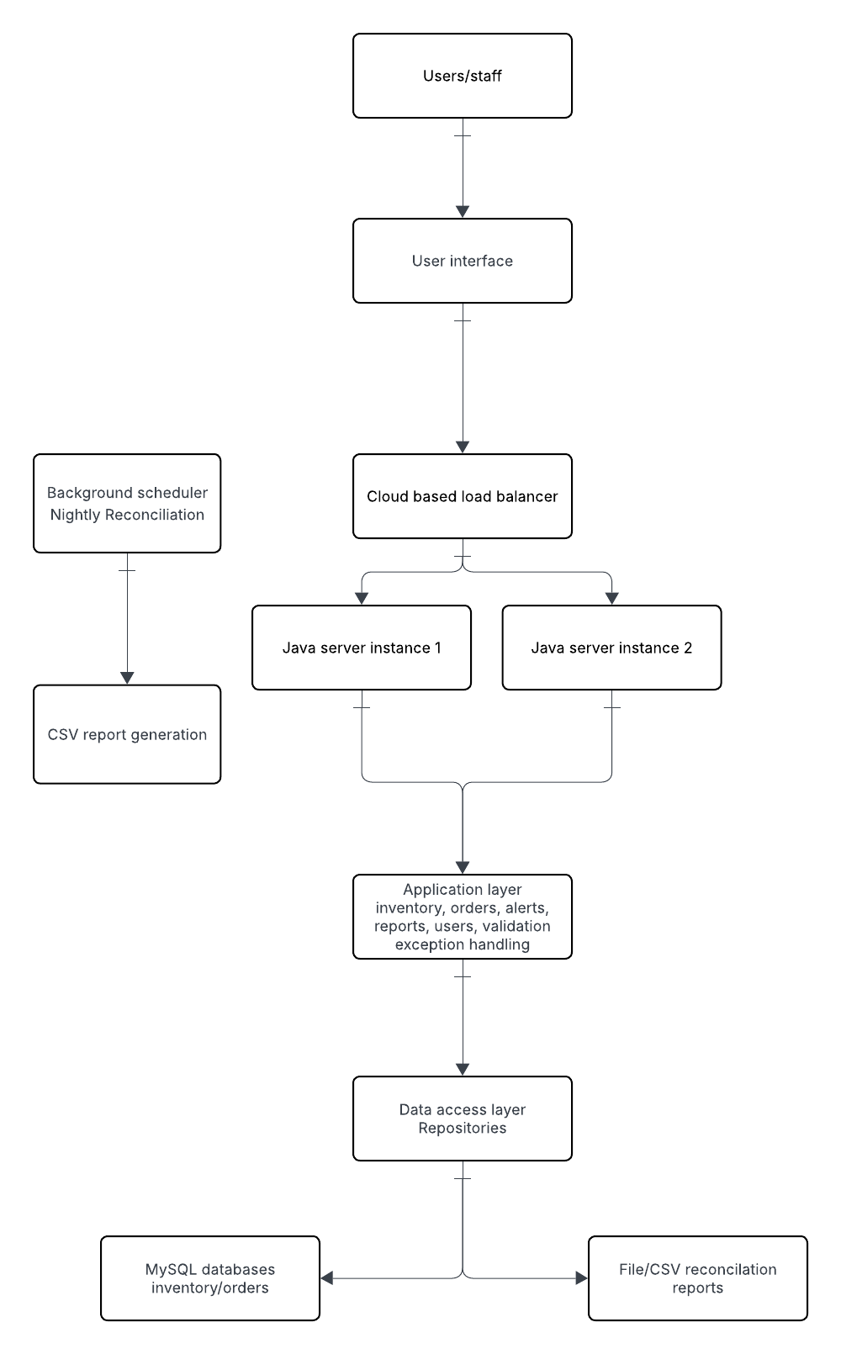
The redesigned system uses a cloud-based architecture with multiple layers. The users interact with the system through the user interface, which sends requests to the cloud load balancer. The load balancer sends the requests to the Java server instances, which allows the system to handle more users by adding more servers when needed. The Java application layer handles the inventory, orders, alerts, and reports using OOP. The data access layer connects the application to the MySQL database and separates the business logic from the database. A scheduler is also used to create the nightly reconciliation reports. This design makes the system easier to maintain, scale, and add new features to.
- Analyze the tradeoffs you considered in selecting your language and paradigm. Include the following:
  - Impacts on performance, extensibility, tooling, or team skills
Some trade-offs I made when choosing Java and OOP are that Java provides good performance and has many tools and libraries, but it can require more code and have a steeper learning curve than simpler programming languages. OOP makes the system easier to organize, maintain, and extend because related data and functions can be grouped into classes, but it also requires the team to learn concepts such as classes, objects, inheritance, and encapsulation. The team may also need to learn new tools and development practices because the original system uses C99 and procedural programming. Overall, I think the benefits of better performance, extensibility, and tooling make Java and OOP a good choice despite the additional learning required (GeeksforGeeks, 2025a; Ozcay, 2025)

Sources

Cornell. (n.d.). CS [45]12[01] spring 2023. Cornell.Edu. https://www.cs.cornell.edu/courses/cs4120/2023sp/notes.html?id=types
Devrim Ozcay — Production Systems Engineer. (2025, December 24). Python vs java: I used both for 5 years. Here’s the real difference. Let’s Code Future. Medium. https://medium.com/lets-code-future/python-vs-java-i-used-both-for-5-years-heres-the-real-difference-9da9981d528f
GeeksforGeeks. (2025a, March 30). Difference between Python and java. GeeksforGeeks. https://www.geeksforgeeks.org/python/difference-between-python-and-java/
GeeksforGeeks. (2025b, April 24). What is imperative programming? GeeksforGeeks. https://www.geeksforgeeks.org/system-design/what-is-imperative-programming/
GeeksforGeeks. (2026a, February 12). C language introduction. GeeksforGeeks. https://www.geeksforgeeks.org/c/c-language-introduction/
GeeksforGeeks. (2026b, June 23). Java OOP(object oriented programming) concepts. GeeksforGeeks. https://www.geeksforgeeks.org/java/object-oriented-programming-oops-concept-in-java/
Gordon, A. (2019, March 6). Functional vs. object-oriented programming: A beginner’s take. Medium. https://medium.com/@adamjgordon24/functional-vs-object-oriented-programming-a-beginners-take-e9ee5d6c665a
Grasp. (n.d.). Grasp. Grasp.Study. Retrieved September 2, 2026, from https://paths.grasp.study/modules/2f8850e3-90d6-4f4c-b97e-f7fec4494986/lessons/a5d5666e-5c68-466f-975e-2696c9ff63c1

OpenAI. (2026). ChatGPT (GPT-5.6 Luna) [Large language model]. https://chatgpt.com/
Used ChatGPT to summarize some sources and help find relevant information from sources.

